CEE_Student_Curriculum_Status.Docx
The official advising forms are at https://apply.eng.hawaii.edu/advising
The course map and copy of your check sheet can assist with making decisions about which classes to take next. This can be done by moving and changing the colored bubbles above the figures below to reflect your current course status. Also, use the bubbles to highlight the progress on the check sheet image on the next page. Below is just an example.
Red = Completed Courses
Yellow = Currently Enrolled Courses
Blue = Next Semester Courses
Green = Courses which you are Eligible to take next semester
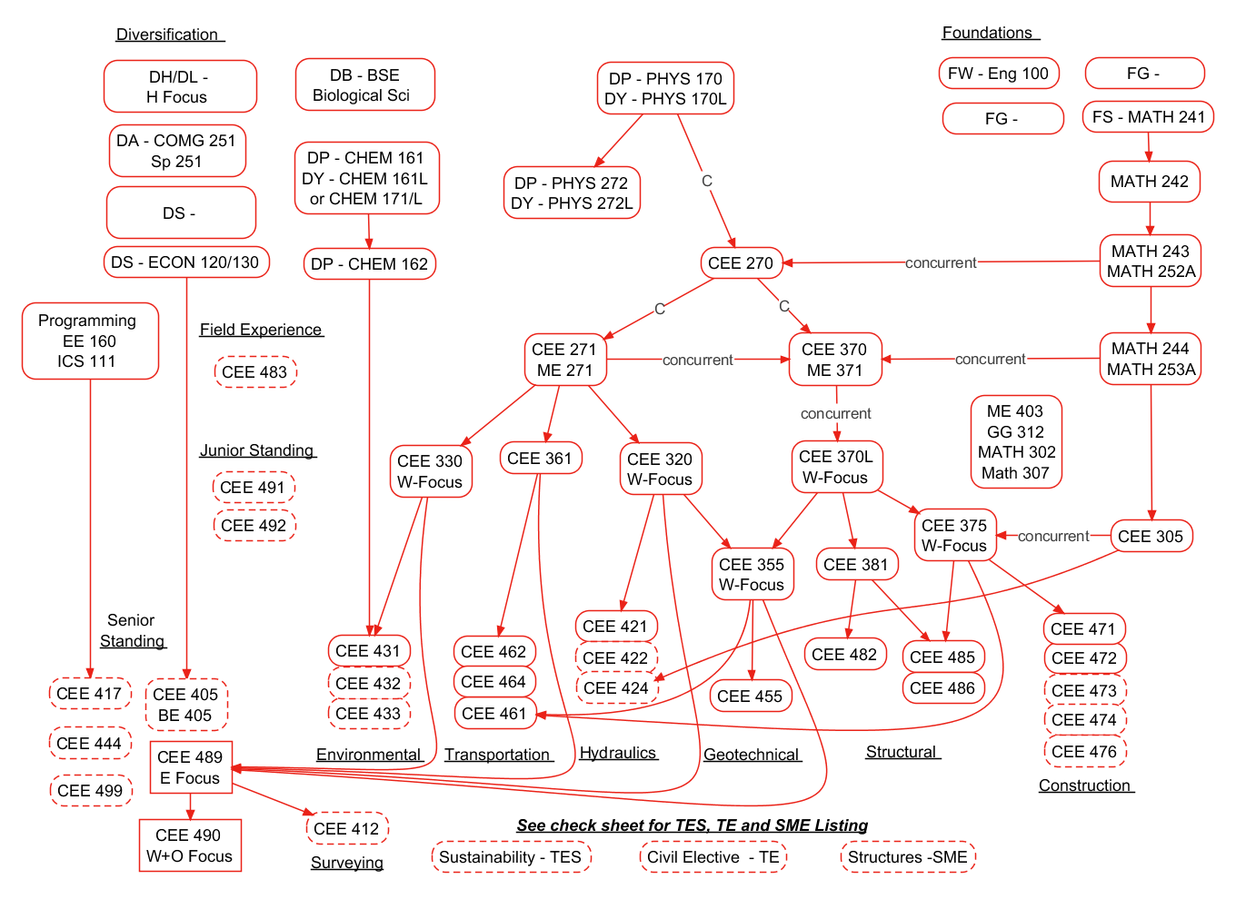
Fall Only: CEE 489, CEE 485
Spring Only: CEE 490, CEE 486

